**Introduction**

The lateral frontal cortex (LFC) is an anatomically diverse area that is implicated in flexible, goal-directed behavior, motor function, and language, amongst many other behaviors. However, the functional-anatomical organization of LFC is highly debated. There have been several attempts to better understand the organization of regions that compose LFC on the basis of its architectonic properties (Petrides, 2005) (Figure 1A) and in-vivo measurements of structural and resting-state functional connectivity MRI (rs-fcMRI). Notably, graph theoretic approaches applied to rs-fc MRI have more precisely characterized the dynamics of the different constituents of this network, and suggested the existence at least five networks in LFC: fronto-parietal (FPN), cingulo-opercular network (CON) (Figure 1B), somatosensory-motor, ventral attention and the default network. However, although such studies map key properties which constrain information processing in LFC, it’s unclear if these boundaries correspond to patterns of brain activity observed during behavioral performance (Amunts & Zilles, 2015; Eickhoff, Paus, Caspers, Grosbras, Evans, Zilles, & Amunts, 2007a; Mattar, Cole, Thompson-Schill, & Bassett, 2015). Moreover, as these methods do not measure the brain’s response to various psychological challenges, they cannot directly identify the (potentially separable) functional associates of LFC sub-regions.

To this end, functional MRI (fMRI) has been extensively used to associate distinct foci of the task-positive network—and in particular regions in frontal cortex—with activation across a wide variety of psychological challenges designed to differ in their demands for control. In turn, these associations have led to detailed, but sometimes conflicting, theories of how information processing in LFC results in flexible, adaptive behavior. For example, activity in left DLPFC has been associated with the resolution of non-response conflict (Milham et al., 2001), the retention of information in working-memory and the maintenance of task-goals in the face of distractors. Others have suggested a rostro-caudal hierarchical axis of cognitive control along lateral prefrontal cortex, citing evidence that posterior LFC is more active for low-level motoric demands whereas fronto-polar regions are active for high-level abstract planning (Badre & D'Esposito, 2009; Botvinick, 2008). Additionally, some cite the robust activation of posterior LPFC, in a region named the inferior frontal junction (IFJ), to suggest that IFJ is critical for set-shifting (Brass, Derrfuss, Forstmann, & Cramon, 2005; Derrfuss, Brass, Neumann, & Cramon, 2005).

Despite the enormous amount of neuroimaging studies, there have been few large-scale efforts to comprehensively map the full range of psychological functions, including dissociable aspects of cognitive control, onto discrete LFC sub-regions. Because most researchers tend to be intimately familiar with a particular psychological domain, most meta-analyses are restricted to a relatively small subset of empirical findings or a small region of interest (e.g. set-switching in IFJ; (Derrfuss et al., 2005). This narrow scope necessarily limits the ability to address the specificity of activation of psychological states across task-positive network anatomy. That is, without considering a wide representative range of psychological states, it is difficult to determine whether particular kinds of tasks preferentially recruit specific regions of the task-positive network. This limitation, widely known as the reverse inference problem (Poldrack, 2006), is particularly acute in regions of the brain that show a high rate of activation across tasks, raising questions about their whether these regions are selectively involved in specific mental functions (Nelson et al., 2010; Yarkoni, Poldrack, Nichols, Van Essen, & Wager, 2011). Thus, by the very nature of the LFC being involved in many tasks across wide variety of psychological domains, this network is particularly difficult to associate to specific mental operations (Figure 1C).

**Figure 1.** A) Cyto-architechtonic parcellation of human lateral frontal cortex based on Petrides and Pandya (1996). B) Control networks of the human brain derived using graph theory in rs-fc MRI based on Power et al., (2012). Frontoparietal network (yellow) and cingulo-opercular network (purple). C) Base rate of activation for voxels across the brain in Neurosynth. Note that key regions of the LFC, such and mid-LPFC, are active in a high percentage of studies.

Here we address these issues by creating a comprehensive mapping between psychological states and LFC using Neurosynth (Yarkoni et al., 2011), a framework for large-scale fMRI meta-analysis composed of nearly 11,500 studies. First, we defined functional sub-regions of LFC at several spatial scales based on their meta-analytic co-activation with the rest of the brain (Robinson, Laird, Glahn, Lovallo, & Fox, 2010; Smith et al., 2009; Toro, Fox, & Paus, 2008). In contrast to cytoarchitechtonic and connectivity based parcellations, the present analysis identified clusters with distinct signatures of functional activation across a wide range of psychological manipulations. In order to avoid restricting ourselves to an unnecessarily small subset of regions and to avoid defining biased or arbitrary boundaries, we clustered the whole cortex and selected regions that had a substantial number of voxels in LFC without using an explicit mask to mask voxels. This analysis revealed 4 whole-brain networks with 15 total regions in LFC. We then characterized each cluster’s psychological profiles using multivariate classification, revealing broad shifts in function between each network in LFC and subtler, yet distinct, functional signatures between regions within each network. Collectively, our results provide a comprehensive functional map of LFC at several anatomical scales using unbiased data-driven methods.

**Materials & Methods**

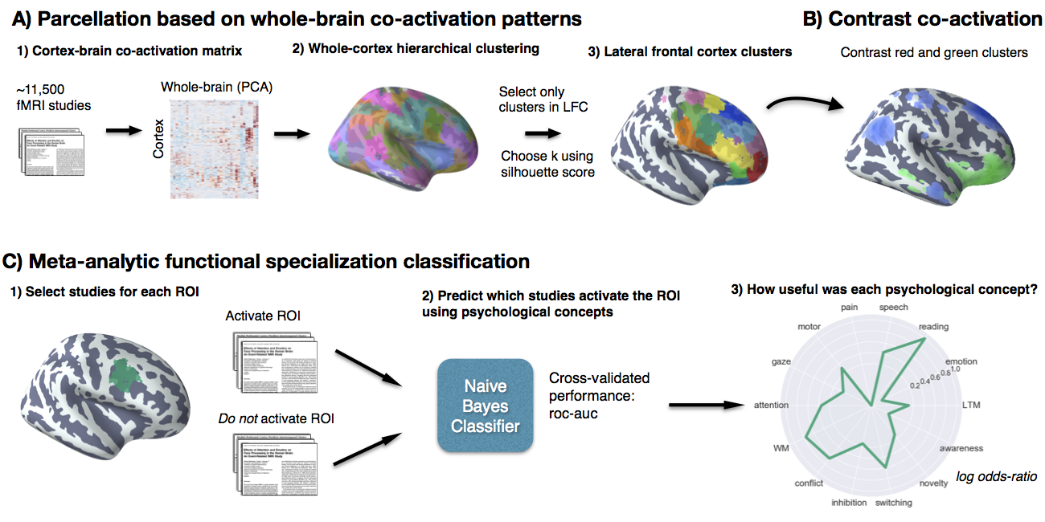**Figure 2. Methods overview.** A) Co-activation across studies with the rest of the brain was calculated for every cortical voxel and whole-brain clustering results were obtained using hierarchical clustering with ward linkage. We chose three spatial scales to focus on using the silhouette method and selected clusters in LFC from the whole-brain clustering solutions. B) We contrasted the whole-brain co-activation of clusters, grouping clusters for comparison that grouped together at coarser spatial scales (i.e. clusters that were in the same network) C) We generated functional preference profiles for each cluster by determining which psychological topics best predicted their activation across studies in the database.

We analyzed version 0.6 of the Neurosynth database (Yarkoni et al., 2011), a repository of 11,406 fMRI studies and over 410,000 activation peaks that span the full range of the published literature. Each observation contains the peak activations for all contrasts reported in a study’s table as well as the frequency of all of the words in the article abstract. A heuristic but relatively accurate approach is used to detect and convert reported coordinates to the standard MNI space (see Yarkoni et al., 2011). As such, all activations and subsequent analyses are in MNI152 coordinate space. The scikit-learn Python package (Pedregosa et al., 2011) was used for all machine learning analyses. Analyses were performed using the core Neurosynth python tools (https://github.com/neurosynth/neurosynth); code and data to replicate these analyses on any given brain region at any desired spatial granularity are available as a set of IPython Notebooks (https://github.com/adelavega/neurosynth-lfc).

Lateral frontal cortex mask

To select voxels in lateral frontal cortex, we defined an anatomical mask by including voxels with a greater than 30% chance of falling in the frontal lobes according to the Montreal Neurological Institute structural probabilistic atlas (Collins, Holmes, Peters, & Evans, 1995; Mazziotta et al., 2001) and excluding medial voxels within 14mm of the midline. To focus on lateral frontal cortex, we excluded voxels that were exclusively located on the orbital surface, ensuring to include lateral orbitofrontal voxels, by removing voxels in the superior and medial orbital gyri according to the AAL atlas and voxels with a greater than 30% probability of falling in ‘Frontal Operculum Cortex’ in the Harvard-Oxford atlas. Finally, we also excluded far ventral voxels (Z < -14mm) that were not excluded using anatomical atlases.

### Co-activation clustering

Next, we clustered individual grey-matter cortical voxels based on their meta-analytic co-activation with the whole brain across studies in the database (Figure 2A). In order to avoid potentially biased or arbitrary cluster boundaries, we clustered the entire cortex and selected clusters for further analysis that fell within our LFC mask. This was particularly important for clusters near the edge of our LFC mask– as functional boundaries may not conform to anatomical boundaries– and at coarse clustering solutions– given the well-established finding that at least 4-5 whole-brain networks include voxels in lateral frontal cortex (Power et al., 2011; Thomas Yeo et al., 2011). For the whole-cortex clustering, we excluded voxels with less than 30% probability of falling in grey matter according to the Harvard-Oxford anatomical atlas and those with very low activation in the database (less than 100 studies per voxel). In general, Neurosynth’s activation mask (derived from the standard MNI152 template distributed with FSL) corresponded highly with probabilistic locations of cerebral cortex, with the exception of portions of dorsal precentral gyrus– which showed low activation although it was more than 50% likely to be in cerebral cortex.

We calculated the co-activation between each cortical voxel and every other voxel in the brain (including sub-cortex) by correlating the target voxel’s activation pattern across studies with the rest of the brain. Activation in each voxel is represented as a binary vector of length 11,406 (the number of studies). A value of 1 indicated that the voxel fell within 10 mm of an activation focus reported in a particular study, and a value of 0 indicated that it did not. Because correlating the activation of every cortical voxel with every other voxel in the brain would result in a very large matrix (112,358 cortical voxels x 171,534 whole-brain voxels) that would be computationally costly to cluster, we reduced the dimensionality of the whole brain to 100 components using principal components analysis (PCA; the precise choice of number of components does not materially affect the reported results). Next, we computed the Pearson correlation distance between every voxel in the MFC mask with each whole-brain PCA component, resulting in a matrix that described the frequency with which each cortical voxel co-activated with the rest of the brain.

As an additional pre-processing step, we z-scored each cortical voxel’s whole-brain co-activation pattern relative to itself. This standardization ensured that the information driving the clustering would be the differences between voxels in their relative co-activation pattern to the rest of the brain, and not be driven by the overall activation rate. That is, if two voxels co-activated with similar voxels across the brain, we should consider them to be relatively similar even if one of those voxels activates more frequently (and thus has slightly stronger correlations with all voxels). This was particularly important as previous clustering of the medial frontal cortex revealed that regions with very high rates of activation (e.g. pre-SMA/mid-cingulate cortex) more readily clustered into clusters with few voxels although differences in their functional associations were minimal. Indeed, preliminary analyses confirmed that z-scoring alleviated this concern. The mean activation rate of each cluster showed no correlation with voxel size when z-scoring was used (r=0.05), as compared to when the raw co-activation matrix was used (r = -0.65) at k = 70 (Figure S1). Additionally, the range of cluster sizes was compressed, resulting in more evenly sized clusters. Cluster sizes ranged from 352 to 4546 voxels using the raw activation, compared to a range of 560 to 2862 voxels using standardized co-activation.

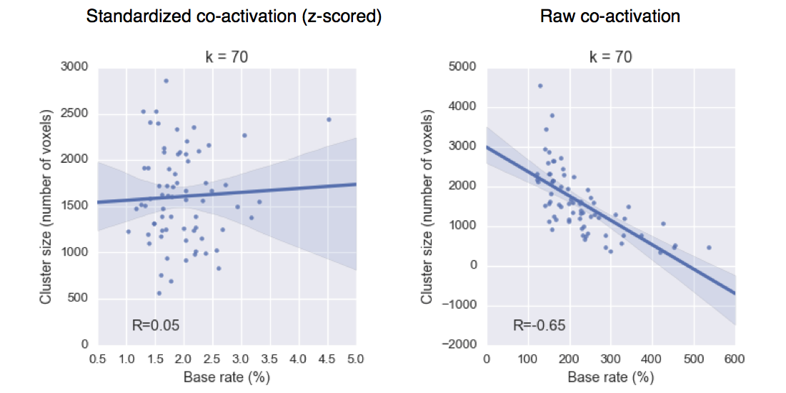

**Figure S1. Relationship between base rate and cluster size.** Standardizing the co-activation matrix prior to cluster reduced the relationship between average base of a cluster and the size in voxels.

We applied hierarchical clustering with ward’s linkage to the normalized co-activation matrix, resulting in a whole-brain linkage matrix. Ward clustering was selected as this algorithm was recommended as the best compromise between accuracy (e.g fit to data) and reproducibility for clustering fMRI data (Thirion, Varoquaux, Dohmatob, & Poline, 2014). However, this clustering algorithm is seldom used for whole-brain clustering because the computational time increases cubically [Θ(N³)] as a function of samples. We employed the fastcluster algorithm (Müllner, 2013)—a package of libraries that enable efficient hierarchical clustering [Θ(N2)]—to achieve whole-brain clustering.

Since the optimality of a given clustering depends in large part on investigators’ goals, the preferred level of analysis, and the nature and dimensionality of the available data, identifying the ‘correct’ number of clusters is arguably an intractable problem (Eickhoff, Thirion, Varoquaux, & Bzdok, 2015; Poldrack & Yarkoni, 2016; Varoquaux & Thirion, 2014). However, in the interest of pragmatism, we attempted to objectively select the number of clusters using the silhouette score, a measure of within-cluster cohesion. Crucially, as we were specifically interested in the fit of the clustering to lateral frontal cortex, we only calculated the silhouette score with respect to voxels within our lateral frontal cortex mask. The silhouette coefficient was defined as (b – a) / max(a, b), where a is the mean intra-cluster distance and b is the distance between a sample and the nearest cluster of which the sample is not a part. Solutions that minimized the average distance between voxels within each cluster received a greater score. Silhouette scores were calculated with respect to voxels within in our LFC mask– to focus on solutions that describe this anatomical area well and due to computational limitations. Once having selected three solutions to focus on (5, 33 and 70 whole-brain clusters), we extracted clusters that had a substantial percentage of voxels in our LFC mask. We varied the threshold required for inclusion depending on the granularity of the solution in order to maximize coverage in LFC without including clusters that had very little presence in LFC. We arrived at 10% of voxels at k=5, 25% of voxels at k=33 and 50% of voxels at k=70.

To understand the anatomical correspondence of the resulting clusters, we consulted a variety of anatomical and cytoarchitechtonic atlases. To locate each cluster anatomically, we used the probabilistic Harvard-Oxford atlas (H-O) that is packaged with FSL. We also compared the location of our functionally defined clusters to Petrides’ (2005) cytoarchitechtonic atlas of lateral prefrontal cortex and the Jülich histological atlas {Mazziotta:2001er, Eickhoff:2007bq}. Regions were assigned names in accordance to Broadmann areas (BA) whenever clusters were sufficient small to correspond to a single area (e.g. ‘area 9/46v’). Clusters were given functional names when they spanned multiple cytoarchitechtonic areas (e.g. IFJ) or multiple clusters spanned a single cytoarchitechtonic area (e.g. PMd & PMv). Note that although names were assigned to ease the discussion of these regions, we do not make strong claims of correspondence between functionally and anatomically defined regions.

### Co-activation profiles

Next, we analyzed the differences in whole brain co-activation between the resulting clusters (Figure 2B) in order to understand the patterns of co-activation that differentiates these clusters. To highlight differences between clusters, we contrasted related sets of clusters. Related clusters were defined as clusters that would go on to join into a larger cluster at a coarser level in the hierarchical clustering tree. For example, in Figure 5b, we contrast the co-activation of two clusters (PMv & PMd) at k=70 that joined into a single motor network cluster at k=5. To do so, we performed a meta-analytic contrast between studies that activated a given cluster, and studies that activated control clusters. The resulting images indicate voxels with a greater probability of co-activating with the cluster of interest than with control clusters. For example, voxels in green in Figure 5b indicate voxels that are active more frequently in studies in which PMv is active than in studies in which PMd is active. We calculated p-values for each voxel using a two-way chi-square test between the two sets of studies and thresholded the co-activation images using the False Discovery Rate (q<0.01). In Figure 7b, q<0.05 was used as too few voxels were significantly different at q<0.01. The resulting images were binarized for display purposes and visualized using the NiLearn library for Python.

### Topic modeling

Although term-based meta-analysis maps in Neurosynth closely resemble the results of manual meta-analyses of the same concepts, there is a high degree of redundancy between terms (e.g. ‘episodes’ and ‘episodic’), as well as potential ambiguity as to the meaning of an individual word out of context (e.g. ‘memory’ can indicate working memory or episodic memory). To remedy this problem, we employed a reduced semantic representation of the latent conceptual structure underlying the neuroimaging literature: a set of 60 topics derived using latent dirichlet allocation (LDA) topic-modeling (Blei, Ng, & Jordan, 2003). This procedure was identical to that used in a previous study (Poldrack, Mumford, Schonberg, Kalar, Barman, & Yarkoni, 2012b), except for the use of a smaller number of topics and a much larger version of the Neurosynth database. The generative topic model derives 60 independent topics from the co-occurrence across studies of all words in the abstracts fMRI studies in the database. Each topic loads onto individual words to a varying extent, facilitating the interpretation of topics; for example, a working memory topic loads highest on the words 'memory, WM, load', while an episodic memory topic loads on 'memory, retrieval, events'. Note that both topics highly load on the word “memory”, but the meaning of this word is disambiguated because it is contextualized by other words that strongly load onto that topic. Although the set of topics included around 25 topics representing non-psychological phenomena-- such as the nature of the subject population (e.g. gender, special populations) and methods (e.g., words such as “images”, “voxels”)—these topics were not excluded as they were rarely the strongest loading topics for any region. For all of our results, we focus on a set of 15 topics that loaded highly onto lateral frontal cortex clusters (Table 1), although all topics were analyzed.

### Meta-analytic functional preference profiles

We generated functional preference profiles by determining which psychological topics best predicted each cluster’s activity across fMRI studies (Figure 2C). First, we selected two sets of studies: studies that activated a given cluster--defined as activating at least 5% of voxels in the cluster-- and studies that did not--defined as activating no voxels in the cluster. For each cluster, we trained a naive Bayes classifier to discriminate these two sets of studies based on psychological topics herein. We chose naive Bayes because (i) we have previously had success applying this algorithm to Neurosynth data (Yarkoni et al., 2011); (ii) these algorithms perform well on many types of data (Androutsopoulos, Koutsias, & Chandrinos, 2000), (iii) they require almost no tuning of parameters to achieve a high level of performance; and (iv) they produce highly interpretable solutions, in contrast to many other machine learning approaches (e.g., support vector machines or decision tree forests).

We trained models to predict whether or not fMRI studies activated each cluster, given the semantic content of the studies. In other words, if we know which psychological topics are mentioned in a study how well can we predict whether the study activates a specific region? We used 4-fold cross-validation for testing and calculated the mean score across all folds as the final measure of performance. We scored our models using the area under the curve of the receiver operating characteristic (AUC-ROC) –a summary metric of classification performance that takes into account both sensitivity and specificity. AUC-ROC was chosen because this measure is not detrimentally affected by unbalanced data (Jeni, Cohn, & la Torre, 2013), which was important because each region varied in the ratio of studies that activated it to the studies that did not.

To generate functional preference profiles, we extracted from the naive Bayes models the log odds-ratio (LOR) of a topic being present in active studies versus inactive studies. The LOR was defined as the log of the ratio between the probability of a given topic in active studies and the probability of the topic in inactive studies, for each region. LOR values above 0 indicate that a psychological topic is predictive of activation of a given region. To determine the statistical significance of these associations, we permuted the class labels and extracted the LOR for each topic 1000 times. This resulted in a null distribution of LOR for each topic and each cluster. Using this null distribution, we calculated p-values for each pairwise relationship between psychological concepts and regions, and reported associations significant after controlling for multiple comparisons using False Discovery Rate with q<0.01. Finally, to determine if certain topics showed greater preference for one cluster versus another, we conducted exploratory, post-hoc comparisons by determining if the 95% confidence intervals (CI) of the LOR of a specific topic for a one region overlapped with the 95% CI of the same topic in another region. We generated CIs using bootstrapping, sampling with replacement and recalculating log-odds ratios for each region 1000 times. The resulting functional profiles are visualized using polar plots through out the results. The ordering of the labels around the polar plot was determined using hierarchical clustering with average linkage, resulting in an order that concisely conveyed the functional differences between LFC’s sub-regions.

**Results**

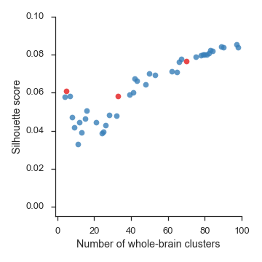  
**Figure 2.** Silhouette scores, a measure of intra-cluster cohesion, for lateral frontal cortex from 4-100 whole-brain clusters. We chose to focus on three levels of granularity– 5, 33, and 70 whole-brain clusters– highlighted in red. Although silhouette score did not strongly indicate any one solution, solutions from 7-32 clusters received relatively low scores, and thus were avoided.

## Hierarchical clustering of lateral frontal cortex

We identified spatially dissociable regions on the basis of shared co-activation profiles with the rest of the brain (Chang, Yarkoni, Khaw, & Sanfey, 2013; Smith et al., 2009; Toro et al., 2008), an approach that exploits the likelihood of a voxel co-activating with another voxel across studies in the meta-analytic database. To avoid defining arbitrary boundaries for regions in the lateral frontal cortex, we clustered the entire cortex and selected clusters that had a significant number of voxels with a an anatomically defined LFC mask– allowing clusters to span beyond LFC and excluding clusters that were primarily outside of LFC.

Because structure-to-function mappings can be identified at multiple spatial scales, we iteratively extracted 3– through 100– flat whole-brain clusters from the full hierarchical solution and assessed their validity using the silhouette score—a commonly used measure of inter-cluster coherence. As we were specifically interested in the fit of LFC clusters, we calculated silhouette scores only with respect to voxels within our LFC mask (Figure 2). Silhouette scores were moderately high from 4-6 clusters, before dipping to relatively low levels from 6-32 whole-brain clusters and rising consistently after 33 clusters. This pattern was consistent with evidence suggesting there are around 6 non-subcortical ‘networks’ (Thomas Yeo et al., 2011) and previous work demonstrating the accuracy of clustering increases monotonically with the number of clusters (Craddock, James, Holtzheimer, Hu, & Mayberg, 2012; Thirion et al., 2014). As such, we chose to focus on three well-spaced levels of granularity, avoiding the trough between 6-32 clusters. At the low end, we chose 5 clusters– as it had the highest silhouette score of network-level solutions– and in the middle we chose 33 clusters as this solution showed a significant increase in silhouette scores from 32 clusters. As silhouette scores did not strongly indicate preference for any particularly solution at more fine-grained levels, we chose to focus on the 70- cluster solution, as at this granularity all LFC clusters became spatially contiguous and separated from distal brain regions in parietal cortex. We primarily used the 5- and 33- cluster solutions to group together regions in the 70– cluster solution for visualization and analysis.

**Figure 3. Whole-cortex co-activation based hierarchical clustering reveals 4 networks in lateral cluster that fractionate into constituent sub-regions.** From a full cortical parcellation, we selected clusters in lateral frontal cortex at three spatial scales. (Left) From five whole-cortex clusters, we identified four clusters with voxels in lateral frontal cortex resembling large-scale whole-brain networks: task-positive control network (red), default network (purple), somatosensory-motor network (green) and the ventral attention network (blue). At 33 whole-brain clusters, these networks fractionated into 10 LFC clusters and at 70 clusters two clusters in the fronto-parietal network further fractionated into 3-4 clusters, resulting in a total of 15 clusters in lateral frontal clusters. At 70 clusters, all clusters were spatially contiguous and a majority of their voxels fell in our LFC mask. Lighter colors indicate voxels outside of LFC in the 5 and 33 cluster solutions.

In the five cluster whole-cortex solution (Figure 3), we identified four clusters with at least 10% of their voxels in lateral frontal cortex, resembling previously described large-scale networks (Power et al., 2011; Thomas Yeo et al., 2011). We identified a somatosensory-motor network, spanning dorsal lateral and medial sensori-motor areas; a network spanning the lateral aspects of Yeo (2011)’s ‘ventral attention’ network and Power (2011)’s cingulo-opercular network; a ‘default network’ closely resembling extensive previous descriptions (Andrews-Hanna, 2012); and a ‘fronto-parietal’ network which also included frontal aspects of Power (2011)’s cingulo-opercular network and Yeo (2011)’s ventral attention network. Although the functional networks we identified were not isomorphic with resting-state networks– in part because our measure of fit suggested choosing a coarser solution than previous studies– these results are consistent with the view that large-scale functional networks supersede the anatomically defined area of lateral frontal cortex as organizational units. Each of these networks, except the ventral-attention network, further fractioned into 2-4 smaller sub-regions in lateral frontal cortex– revealing potentially dissociable sub-regions within each network. Two clusters in the fronto-parietal network further fractionated into 3-4 sub-regions, resulting in a total of 15 LFC sub-regions from 70 whole-cortex clusters.

To better understand the organization and function of each of these 15 lateral frontal clusters, for each network separately, we describe their anatomical and functional correspondence. Because the ventral attention network only had 1 cluster in lateral frontal cortex, we grouped this cluster with the spatially nearby and functionally similar clusters of the somatosensory-motor network for comparison. To precise locate each cluster, we compare them to previously defined anatomical (Harvard-Oxford) and cytoarchitechtonic (Eickhoff, Paus, Caspers, Grosbras, Evans, Zilles, & Amunts, 2007b; Petrides, 2005) atlases. In addition, to provide direct insight into the functions of the clusters we identified, we applied two approaches. First, we determined which other brain regions co-activate with each cluster across studies, revealing distinct whole-brain functional networks for each cluster. Second, we used semantic data from Neurosynth to determine which psychological states predict the activation of each cluster, resulting in a unique meta-analytic functional preference profile for each.

**Ventral attention and somatosensory-motor networks**

Anatomical correspondence

In the far posterior aspects of lateral frontal cortex, we identified two networks with at least 1 region primarily in LFC: somatosensory-motor and ventral attention (Figure 4a). Outside of LFC, the somatosensory-motor network also spanned SMA and posterior midcingulate cortex (MCC) on the medial surface, and extended posteriorly across parietal cortex– likely also spanning much of a previously described ‘dorsal attention’ network (Yeo et al. 2011). We identified two clusters within this network that were located almost entirely in LFC: dorsal and ventral lateral premotor cortex– PMd and PMv, respectively. Both of these areas were located in the dorsal half of BA 6 (Eickhoff, Paus, Caspers, Grosbras, Evans, Zilles, & Amunts, 2007a), although PMd was located slightly more anterior; PMv slightly encroached into primary motor cortex as a result of its slightly more posterior location. Notably, PMd also included a small amount of voxels outside of LFC in the right primary somatosensory cortex. Investigation at finer-grained levels of granularity indicated these voxels remained grouped even past 100 whole-cortex clusters, suggesting the co-activation of these regions is strongly coupled. At the coarser solution of k=33, PMd grouped with the medial supplementary motor area (SMA), suggesting these regions perform relatively similar roles in motor function.

Immediately ventral to these two regions was the only lateral frontal cluster from the ventral attention network. This center of this cluster was located in the fundus of the central sulcus, and extended onto ventral primary motor cortex (PMC) and ventral primary somatosensory cortices (SCX); as such, we refer to this cluster as “PMC/SCXv”. The lack of a clean functional distinction between clusters within and outside LFC, and across distinct cytoarchitechtonic areas suggests that anatomical boundaries do not necessarily reflect task-dependent functional boundaries. Meta-analytic co-activation profiles

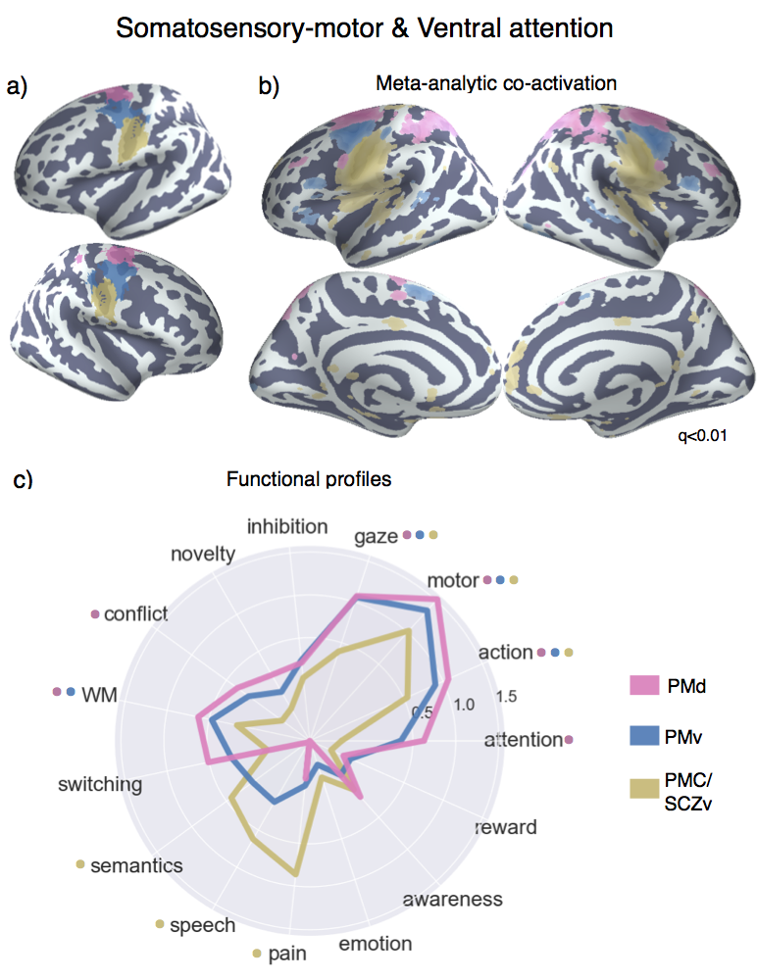

**Figure 4. Lateral frontal regions of somatosensory-motor and ventral attention networks.**   
a) Individual clusters projected onto an inflated surface. PMD and area PMv belonged to the somatosensory-motor network and area PM/SCZv to the ventral attention network b) Differences in co-activation. Colored voxels activated more frequently in studies in the seed cluster of the same color was also active. b) Functional preference profiles for each cluster, revealing distinct psychological signatures. Strength of association is measured in log odds-ratio (LOR), and permutation-based significance (q<0.05) is indicated next to each topic by color-coded dots corresponding to each cluster.

Next, we examined differences in co-activation with the rest of the brain across fMRI studies, in order to better understand the functional differences between these regions (Figure 4b). To do so, we directly contrasted co-activation patterns of the three clusters– i.e., we sought to identify voxels across the brain that co-activated to a stronger degree with each cluster than with the other two (note that each cluster trivially co-activates with itself, as studies that activate a given cluster necessarily show robust activity within that cluster). PMd showed greater co-activation across parietal cortex, extending from the inter-parietal sulcus (IPS) into the superior parietal lobule (SPL), and mid-DLPFC– regions implicated in executive function and goal directed cognition. PMv, on the other hand, showed greater co-activation with ventrolateral prefrontal cortex (i.e. IFG pars orbitals) and pre-SMA. Although co-activation cannot directly speak to the functional role of these regions, these results suggest dorsal and ventral premotor cortex perform dissociable motoric roles. Finally, PMC/SCXv showed a somewhat more distinct pattern, exhibiting greater co-activation with the posterior insula (pIns) and secondary somatosensory cortex (SII), posterior MCC and anterior medial prefrontal cortex (mPFC). This more distinct pattern is consistent with PMC/SCXv’s grouping into a different network from the two premotor clusters.

Meta-analytic functional preference profiles

Next, we used a data-driven approach that surveyed a broad range of fMRI studies to determine which psychological states differentially recruited each LFC cluster (Figure 4c). For each cluster, we trained a multivariate classifier to predict if studies activated the cluster using a set of 60 psychological topics derived by applying a standard topic modeling approach to the abstracts of articles in the database (Poldrack, Mumford, Schonberg, Kalar, Barman, & Yarkoni, 2012a). From the resulting fitted classifiers, we calculated a measure of how strongly each topic indicated that a study activated each cluster (measured as the log odds-ratio [LOR] of the probability of each topic in studies that activated a given cluster to the probability of the same topic in studies that did not activate the cluster). Values over 0 indicate that the presence of that topic in a study predicts activity in a given region. We report the results of 15 psychological topics that loaded strongly onto LFC regions (Table 1) and restrict interpretation to significant associations using False Discovery Rate (FDR; q < 0.05). In addition, whenever we comparatively discuss sets of regions, we determined significance if the 95% confidence interval (CI) of a given topic did not overlap between two regions. As the latter comparisons are post-hoc and exploratory, caution in interpretation is warranted. A full reference figure of 95% CI for all regions is reported as Supplementary Figure 2.

All three sub-regions showed relatively similar functional signatures, justifying their grouping. However, PMC/SCXv showed the most distinct signature, consistent with the relatively different co-activation pattern exhibited by this region. Notably, all three clusters were significantly associated with motor function (e.g. ‘motor’ & ‘gaze’), although this relationship was stronger for the two pre-motor clusters. However, only pre-motor clusters were associated with higher-level motor planning (i.e. ‘action’) and working-memory– suggesting these clusters are involved in relatively high-level motoric function. Moreover, PMd was significantly associated with ‘conflict’ and ‘attention’, consistent with its stronger co-activation with regions implicated in attention control such as lateral parietal cortex and DLPFC. In contrast, ‘PMC/SCZv’ was significantly associated with language topics (i.e. ‘semantics’ and ‘speech’), consistent with its relatively proximity to the primary auditory cortex. Moreover, this cluster was strongly associated with ‘pain’, consistent with its co-activation with pIns and SII– key pain processing regions (Rolls et al., 2003; Wager et al., 2013). In sum, although clusters in posterior lateral frontal cortex showed relatively similar functional profiles– focused primarily on motor function– the present results suggest a dorsal-ventral gradient of function, with more dorsal regions being more involved in attentional control, and more ventral regions with language and pain processing.

**Fronto-parietal network**

**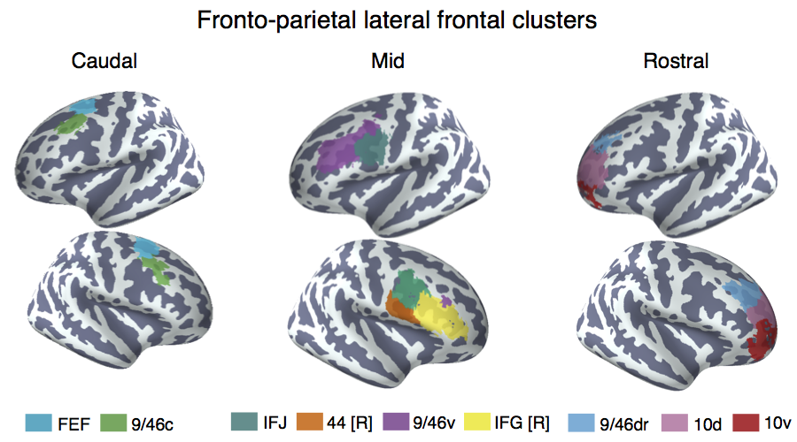  
Figure 5. Lateral frontal clusters of the fronto-parietal network.**   
We identified 9 clusters with at least 50% of their voxels in LFC from 70 whole-cortex clusters of granularity. Left) Two clusters were located in more caudal of prefrontal cortex. Although these clusters did not cluster together, we have grouped them due to their spatial proximity. Middle) Four clusters located in mid-lateral pre-frontal cortex, which grouped together into single cluster at 33 whole-cortex clusters of granularity. Right) Three clusters located in rostrolateral pre-frontal cortex– encompassing the majority of lateral frontal pole– which grouped together into a single cluster at 33 whole-cortex clusters of granularity. Clusters were assigned a name corresponding to cytoarchitechtonic areas whenever possible. In cases where the region spanned many cytoarchitechtonic areas, anatomical (e.g. inferior frontal junction [IFJ]) or functional (frontal eye fields [FEF]) names were assigned.

Anatomical correspondence

The majority of lateral frontal cortex belonged to a fronto-parietal whole-brain network that additionally spanned the lateral parietal cortex (LPC), anterior insula (aI), pre-SMA, mid-cingulate cortex (MCC) and the precuneus outside of LFC. This network resembled previous descriptions of the fronto-parietal network in addition to regions sometimes ascribed to cingulo-opercular Power et al., 2011) or ventral attention networks (Yeo et al., 2011), such as MCC. This network fractionated into nine LFC clusters in the 70 whole-brain solution (Figure 5). Four of these clusters grouped at k=33 into a single ‘mid’ lateral prefrontal cluster, and three grouped into a ‘rostral’ lateral prefrontal cluster. Two additional clusters did not group until much later in the clustering process, but we have organized them into a ‘caudal’ group due to their spatial proximity in caudal LPFC.

In caudal LPFC, we identified two distinct dorsolateral clusters (Figure 5; left panel). The most posterior cluster was located anterior to the premotor cortex in dorsal BA8 that extended from lateral superior frontal gyrus, into middle frontal gyrus dorsal to the intermediate frontal sulcus (i.e. area 9/46d). We refer to this cluster as the frontal eye fields (FEF) as the location of this cluster was consistent with the functionally defined frontal eye fields (FEF)– a region important to volitional eye saccades (Paus, 1996). Lying anterior and ventral to FEF, we identified a cluster that spanned a small area of caudal area 9/46 (9/46c), extending across the intermediate frontal sulcus into dorsal and ventral cytoarchitechtonic sub-divisions. Although this cluster extended well into mid-DLPFC, as far as area 9/46v, it was notable that this cluster did not group with other mid-LPFC clusters in whole-brain clustering, suggesting this cluster may exhibit a dissociable functional signature.

Anterior and ventral to caudal LPFC, we identified four clusters that grouped together into a single cluster at 33 clusters of granularity (Figure 5, middle panel). These four clusters spanned most of what many refer to as ‘mid’ lateral prefrontal clusters. Most dorsally we identified a cluster that spanned the majority of area 9/46v ventral to the intermediate frontal sulcus, extending well into the fundus of the inferior frontal sulcus. Although this cluster was primarily lateralized to the left hemisphere, it did include a small number of voxels in right 9/46v. As such, we refer to this cluster as ‘9/46v’. In the right hemisphere, we identified a cluster that spanned the entirety of BA45. This cluster, which we refer to as right IFG (IFG [R]), extended dorsally into the inferior frontal sulcus near area 9/46v. Notably, the contralateral analogue of this cluster was not found in the fronto-parietal network. This asymmetry is consistent with the observation that right IFG is consistently observed in goal-directed cognition, and hence groups with regions in the fronto-parietal network, whereas left IFG is more consistently involved in language. Anterior to both of these clusters, we identified a bilateral cluster located in the caudal end of the inferior frontal sulcus, spanning precentral, inferior frontal and middle frontal gyri. The cluster was mostly buried in the fundus of the sulci and is consistent with previous reports, and co-activation based parcellations, of an IFJ region (e.g. MNI coordinates 48, 4, 33; (Brass et al., 2005; Muhle-Karbe et al., 2015). Finally, ventral to this cluster in the right hemisphere, we identified a fourth cluster, which was located in the posterior end of IFG, likely spanning BA44 and abutting BA6. We refer to this cluster as ’44 [R]’.

At the most anterior portion of LFC, we identified three bilateral clusters which grouped together in the k=33 solution into a single fronto-polar cluster (FP) (Figure 5, right panel). These three clusters spanned the entirety of lateral BA10 and fractionated in along a ventral-dorsal axis, consistent with a recent DTI parcellation (Orr, Smolker, & Banich, 2015). Notably, none of these cluster extended into medial aspects of BA10, or extend ventrally into orbitofrontal cortex, consistent with recent cytoarchitechtonic evidence of a lateral-medial distinction in frontal pole (Bludau et al., 2014). The most dorsal of these three clusters extended well into dorsal portions of area 9/46d, bilaterally. As such, we refer to this cluster as 9/46d. The next two clusters separated along the most anterior portion of the brain in BA10; as such, as refer to these clusters as ‘10d’ and 10v’, respectively.

**Figure 6. Meta-analytic co-activation contrast between lateral frontal regions in the fronto-parietal network.**

Colored voxels indicate significantly greater co-activation with the seed region of the same color (see Figure 5) than other lateral frontal regions in the fronto-parietal network. Images are presented using neurological convention and were whole-brain corrected using a false discovery rate (FDR) of q = 0.00001 to prevent excessive overlap. More liberally thresholded images for each region can be found in Supplemental Figure 3.

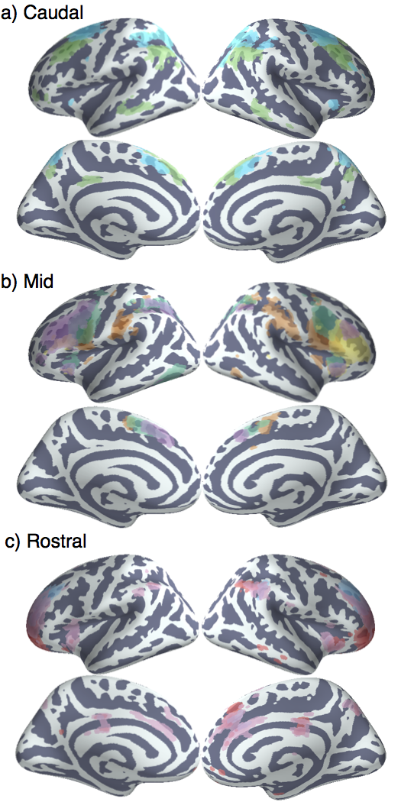

Meta-analytic co-activation profiles

Next, we contrasted the whole-brain co-activation of fronto-parietal LFC clusters, revealing distinct patterns for each region (Figure 6). We observed a striking pattern of co-activation differences, such that the majority of clusters co-activated with distinct sub-portions of similar areas. In all of these cases, the areas in question were high-base rate, association areas of cortex, such as lateral parietal cortex, medial frontal cortex (MFC) and the insula. Across parietal cortex, each LFC cluster co-activated most strongly with distinct areas across a gradient extending from tempo-parietal junction (TPJ) to the lateral parieto-occipital sulcus. For example, clusters ‘9/46c’ and all fronto-polar clusters showed greater co-activation with parietal cortex ventral to the intraparietal sulcus. In contrast, ‘FEF’ and all four ‘mid’ LPFC clusters showed greater co-activation with the interparietal sulcus itself and areas slightly dorsal to it. This gradient of co-activation across LPC suggests that different areas of LFC communicate with distinct parietal areas that may represent distinct information for further high-level processing.

Similarly, all clusters except right IFG co-activated most strongly with distinct portions of pre-SMA and MCC. Generally, more anterior clusters co-activated more strongly with more anterior portions of pre-SMA/MCC. For instance, cluster ‘10d’ co-activated most strongly with a portion of mid-cingulate cortex that extended into perigenual ACC. In contrast, cluster ‘44 [R]’ co-activated with a more posterior portion in the supplementary motor area (SMA). Given the importance of MFC for motoric and executive function, and the strong coupling of these regions at a network, these results suggest that distinct areas of lateral frontal cortex work in concert with distinct medial areas to achieve goal-directed cognition.

In addition to the differences in co-activation across parietal and frontal cortex, we observed strong differences the insula. Cluster 44 [R] showed the most distinct pattern, showing strong co-activation with posterior insula (pI), an region for pain and sensorimotor processing (Chang et al., 2013). In contrast, the remaining clusers showed strong co-activation with different portions of anterior insula (aI). For instance, IFJ co-activated most strongly with dorsoanterior Insula, a sub-region implicated in goal-directed cognition. In contrast, areas 10d and 10v generally showed greater co-activation with ventroanterior insula, which has been implicated in chemo-sensory processing.

In sum, the primary differences in co-activation across fronto-parietal regions in lateral frontal cortex were within highly active ‘task-positive’ association areas, perhaps due to a requirement for different types of multi-modal information depending on the type of cognitive control that needs to be exerted by each region. The exceptions to this pattern were area 9/46c and the two clusters in BA10, which showed stronger co-activation areas of the default network, including vmPFC and PCC. This pattern is consistent with the hypothesis that frontal pole may serve as a relay between the task-positive front-parietal network and the internally-oriented default network (Burgess, Dumontheil, & Gilbert, 2007).

Meta-analytic functional preference profiles

Having observed distinct patterns of co-activation between the fronto-parietal LFC clusters we identified, we probed the semantic data in Neurosynth to determine if psychological states differentially recruited each cluster (Figure 7). Consistent with distributed role for the fronto-parietal network in goal-directed cognition, all nine clusters were significantly associated with working-memory, all clusters except 10v were associated with conflict, and six clusters were associated with switching. The present results are inconsistent with focal anatomical locations for high-level executive processes and instead suggest these processes likely rely on distributed firing across the network to perform goal-directed cognition in the face of interference and conflict.

**Figure 7. Meta-analytic functional preference profiles for lateral frontal regions in the fronto-parietal network.**

Each cluster was profiled to determine which psychological concepts best predicted its activation. Each of the three functional groups we identified showed distinct functional profiles, although appreciable variation was observed for each individual cluster. Strength of association is measured in log odds-ratio (LOR), and permutation-based significance (p<0.001) corrected using a false discovery rate (FDR) of q = 0.01 is indicated next to each psychological concept by color-coded dots corresponding to each region.

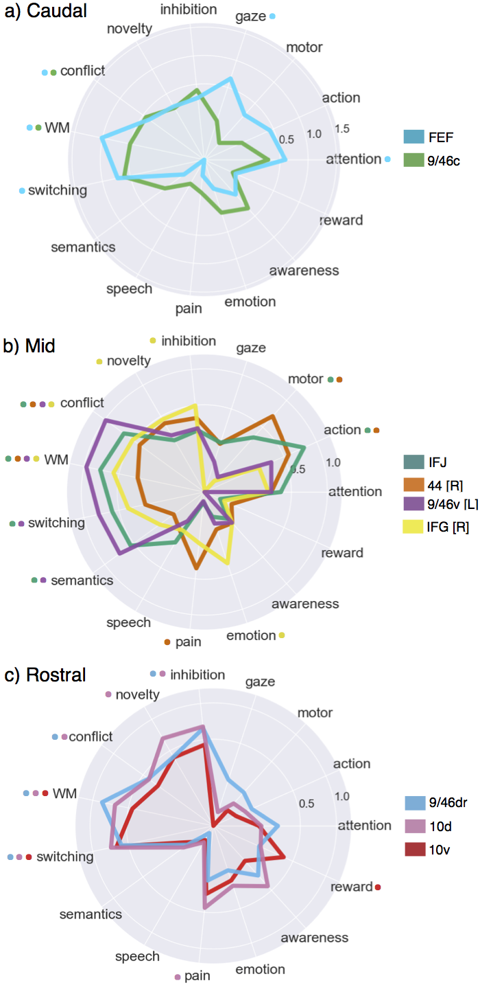

Caudal fronto-parietal LFC

Despite the overall functional similarities between these regions across core aspects of cognitive control, each cluster exhibited distinguishing functional characteristics. Consistent with the anatomical label assigned to it, FEF was the only cluster significantly associated with saccadic eye movements (i.e ‘gaze’), and was also associated with ‘attention’. This pattern suggests that the FEF works in concert with other fronto-parietal regions in a supporting role by directing attention to relevant stimuli in the external environment to support downstream information processing. Moreover, it is notable FEF was significantly associated with ‘working-memory’, as this region has been recently implicated in a critical role in the oculomotor delayed response task in a recent lesion study (Mackey, Devinsky, Doyle, Meager, & Curtis, 2016).

Cluster 9/46 showed the least distinctive functional signature, showing no significant associations outside of working memory and conflict. Given that this cluster did not join with other fronto-parietal regions until much later in the clustering process suggests this region may be involved in psychological states not well characterized by our topic model, or is involved in a domain-general process that supersedes these more specific processes.

Mid fronto-parietal LFC

In mid-LPFC, cluster 9/46v and IFJ showed similar functional profiles, exhibiting robust associations with various executive functions (e.g. ‘wm’, ‘conflict’, ‘switching’) in addition to semantics. Cluster 9/46v showed a particularly strong association with executive control processes, as the relationship between this region and ‘conflict’ was significantly greater than all other fronto-parietal clusters except IFJ. These results are consistent with a hypothesized role for mid-DLPFC as the seat of high-level executive processes, although the cluster we identified is located more ventral– extending into inferior frontal sulcus– than may be hypothesized.

With respect to IFJ, these results are consistent with the hypothesis that IFJ is involved in switching (Brass et al., 2005; Derrfuss et al., 2005) and is underappreciated in its contributions to cognitive control. However, many other clusters were similarly strongly associated with switching, suggesting IFJ is not likely to be focally responsible for this phenomenon. However, IFJ was also characterized by its significant association with low and high level motor function (i.e. ‘motor’, ‘action’)– an association shared only by 44 [R] in the fronto-parietal network. As the only region strongly associated with both executive processes and motor function, IFJ is well positioned as a unique mediator between high-level plans and task-sets and low level motoric innervation. The potential ubiquity of such a function may explain its extremely high rate of activation across a wide range of studies. In contrast, cluster 44 [R]– with its much lower associations with executive functions and a significant association with ‘pain’– may be important for introducing negative affective signals that may require an immediate change in plans into such a process. Notably, a similar role has been attributed to mid-cingulate cortex (MCC).

Finally, rIFG, showed a relatively distinct functional signature to other mid LPFC clusters. This cluster was more weakly associated with conflict, working memory and switching– processes not typically attributed to ventral LPFC. In contrast, rIFG showed a significant association with ‘inhibition’, consistent with an extensive literature on the role of right inferior frontal gyrus in inhibitory processes (Aron, Fletcher, Bullmore, & Sahakian, 2003; Aron, Robbins, & Poldrack, 2004; Depue, Curran, & Banich, 2007). rIFG was also strongly associated with ‘emotion’, consistent the hypothesis that this region is crucial for effective emotion regular and reappraisal (Frank, Dewitt, & Hudgens-Haney, 2014; Opialla et al., 2015; Wager, Davidson, Hughes, Lindquist, & Ochsner, 2008). However, rIFG was also significantly associated with ‘novelty detection’, consistent with a recent hypothesis that inhibitory control may require monitoring the environment for changes in context rather than motoric stopping (Chatham et al., 2012; Munakata et al., 2011). However, the relationship between ‘inhibition’ and ‘novelty’ and rIFG was not particularly strong or significantly greater than with other regions, suggesting rIFG may play a more general role that is not well encapsulated by the present topics.

Rostral fronto-parietal LFC

The three most rostral regions of the fronto-parietal network showed relatively similarly functional profiles, consistent with their similar pattern of co-activation. Like other clusters in the FPN, these fronto-polar clusters showed robust, although not remarkably strong associations with various executive processes. Notably, both clusters ‘9/46dr’ and ‘10d’ showed a robust association with ‘inhibition’, while cluster ‘10d’ was also significantly associated with ‘novelty’. This pattern was remarkably similar to that shown by ‘rIFG’, suggesting inhibitory control is not the sole provenance of that area. However, these regions were associated with ‘novelty’ and ‘inhibition’ but not ‘emotion’ (in contrast to rIFG). This pattern is potentially consistent with hierarchical models of control in LPFC, which postulate that more rostral regions represent more abstract goals (Badre & D'Esposito, 2009; Botvinick, 2008). This is particularly plausible in light of the lack of association between these regions and any low-level processes such as motor function or affective processing. However, it’s not clear the present pattern of results suggests that these rostral areas are more abstract in nature than mid-DLPFC (e.g. cluster 9/46v), unless ‘novelty’ detection is construed as a more abstract process than conflict processing.

Finally, the most ventral fronto-polar region, cluster ‘10v’, showed a more distinct pattern, with more weak associations with all executive processes. In contrast, this cluster was significantly association with ‘reward’, consistent with its location near orbitofrontal cluster and its co-activation with vmPFC. These results are consistent with existing hypotheses that suggest that ventral frontal pole is particularly important for relying information that represents the value of stimuli to effectively guide goal-directed behavior (Orr et al., 2015).

**Default network**

Anatomical correspondence

The final network we identified in lateral frontal cortex showed a strong resemblance to previous descriptions of the ‘default network’ (Andrews-Hanna, 2012; Power et al., 2011; Thomas Yeo et al., 2011), spanning anterior mPFC, PCC outside of LFC. Within LFC, we identified three distinct clusters (Figure 8a). The first two clusters were positioned adjacent to each other in ventrolateral prefrontal cortex. The larger of the two spanned the entire left inferior frontal gyrus (IFG [L]) while the third cluster was positioned immediately anterior to it in lateral orbitofrontal cortex extending to IFG orbitalis in the right hemisphere. The latter region was consistent with cytoarchtechtonic area 47/12. Most dorsally, we identified a third cluster consistent with BA9 (Petrides, 2005) extending from superior frontal gyrus to dorsal middle frontal gyrus across the superior frontal sulcus. The grouping of this cluster with the default network instead of fronto-parietal is consistent with various parcellations based on rs-fMRI and the finding that this region lacks input from lateral and medial parietal cortex (Petrides & Pandya 1984, 1999; Cavada & Goldman-Rakic 1989; Andersen et al. 1990). Thus, despite the proximity of this region to area 9/46v, the results of the clustering suggest this region will exhibit a distinct functional profile from fronto-parietal clusters.

Meta-analytic co-activation profiles

Next, we contrasted the whole-brain co-activation of fronto-parietal LFC clusters, revealing distinct patterns for each region (Figure 8b). Left IFG showed the most distinct pattern, co-activating with portions of the fronto-parietal network such as mid-DLPFC and pre-SMA. This pattern is consistent with the fact that this clusters contralateral homologue grouped with the fronto-parietal network; thus, although this region’s connectivity was similar enough to other default network regions to form a part of this network, this region may not be fully dissociable from fronto-parietal function. Left IFG also showed stronger co-activation with middle temporal gyrus, consistent with a possible role in language. In contrast, cluster 47/12, which is located anatomically near left IFG, showed strong co-activation with orbitofrontal cortex, vmPFC, PCC and anterior temporal lobe– key regions of the default network. Similarly, cluster 9 showed robust co-activation with the rest of the default network, firmly placing this region within this network and not the fronto-parietal network.

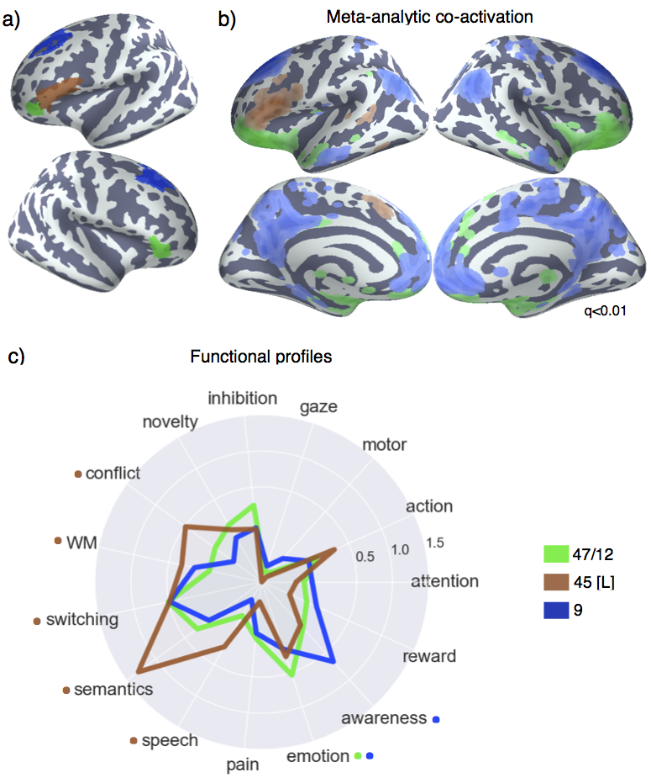

**Figure 8. Lateral frontal regions of the default network**a) Individual clusters projected onto an inflated surface. b) Differences in co-activation between the three regions. Colored voxels activated more frequently in studies in the seed cluster of the same color was also active. b) Functional preference profiles for each cluster, revealing distinct psychological signatures for each sub-region. Strength of association is measured in log odds-ratio (LOR), and permutation-based significance (p<0.001) is indicated next to each psychological concept by color-coded dots corresponding to each region.

Meta-analytic co-activation profiles

Having observed distinct patterns of co-activation between default LFC clusters, we probed the semantic data in Neurosynth to determine if psychological states differentially recruited each cluster (Figure 8c). Consistent with left IFG’s co-activation with other fronto-parietal regions, this cluster was significantly associated with various executive functions, including ‘conflict’, ‘WM’ and ‘switching’. This finding further highlights the distributed nature of core executive processes across region beyond the fronto-parietal network. However, it is notable left IFG was not associated with inhibition, consistent with the strong lateralization of this process onto rIFG. Finally, consistent with this region’s overlap with Broca’s area and co-activation with the middle temporal gyrus, left IFG was significantly associated with language topics. Notably, left IFG was the only lateral prefrontal region associated with ‘speech’. Although this finding is not surprising, the requirement in speech production to access internally oriented representations (i.e. autobiographical memories) as well as drive motoric function for speech may explain why this region seemingly shares attributes with both the default and fronto-parietal networks.

The two other lateral frontal clusters of the default network showed very distinct functional profiles, showing no association with any executive processes. This is particularly notable for area 9, given its anatomical proximity to mid-DLPFC and the FEF. Instead, both regions showed robust associations with ‘emotion’, consistent with their placement into the default network. Notably for area 47/12, despite its proximity to orbitofrontal cortex and cluster 10v, this cluster was not significantly associated ‘reward’, suggesting a dissociation between these affective processes. Finally, area 9 was the only cluster associated with a topic representing conscious awareness. As such, a potential role for this cluster that would explain its proximity to mid-DLPFC would be to make an individual consciously aware of high-level goals represented and acted upon in fronto-parietal network.

|  |  |
| --- | --- |
| Topic name | Top loading words |
| action | action actions motor goal mirror planning imitation execution directed |
| arithmetic | number numerical arithmetic numbers digit calculation mental symbolic distance |
| conflict | conflict interference incongruent stroop congruent selection competition color reaction |
| errors | error errors monitoring correct feedback creative creativity driving incorrect |
| fear | fear anxiety threat conditioning cs extinction conditioned aversive phobia |
| inhibition | inhibition inhibitory stop motor sustained nogo transient suppression inhibit |
| LTM | memory retrieval encoding recognition episodic items recall words memories |
| novelty | target targets novelty oddball distractor distractors deception mismatch identity |
| reading | reading sentences language comprehension sentence word syntactic phonological chinese |
| semantics | semantic words word lexical verbs abstract meaning verb nouns retrieval |
| switching | switching rule executive switch rules flexibility shifting aggression shift |
| WM | memory working wm load verbal maintenance delay encoding capacity |

Table 1. Topics most strongly associated with lateral frontal regions. Nine strongest loading words for each topic are listed, in descending order of association strength.

**Discussion**

Discussion points:

* Cognitive control processes are more distributed than some would expect, and definitely implicate the cingulo-opercular network
* Fit to existing models:
  + Rostro-caudal axis
    - Possibly, when comparing DLPFC to RLPFC. However, many cognitive control functions are distributed, which is in contrast to theory. In particular, memory is hypothesized to show a hierarchical order, and it is among the most distribution of fuctions
  + IFJ and set switching?
    - While our results suggest that IFJ is indeed involved in set-switching and cognitive control more than some people have claimed, other regions in the FPN are much more robustly associated with switching, suggesting this may not be IFJ’s primary role
    - IFJ has very high activation rate, so it is likely to being doing something fundamental that underlies many tasks
    - lIFJ was involved with ‘action’. As such, it may be that rIFJ is indeed a link between high-level representations in dLPFC and motor regions.

## **References**

Amunts, K., & Zilles, K. (2015). Architectonic Mapping of the Human Brain beyond Brodmann. *Neuron*, *88*(6), 1086–1107. http://doi.org/10.1016/j.neuron.2015.12.001

Andrews-Hanna, J. R. (2012). The Brain's Default Network and Its Adaptive Role in Internal Mentation. *The Neuroscientist*, *18*(3), 251–270. http://doi.org/10.1177/1073858411403316

Androutsopoulos, I., Koutsias, J., & Chandrinos, K. V. (2000). An evaluation of naive bayesian anti-spam filtering. *Proceedings of the Workshop on Machine Learning in the New Information Age*, 9–17.

Aron, A. R., Fletcher, P. C., Bullmore, E. T., & Sahakian, B. J. (2003). Stop-signal inhibition disrupted by damage to right inferior frontal gyrus in humans. *Nature*.

Aron, A. R., Robbins, T. W., & Poldrack, R. A. (2004). Inhibition and the right inferior frontal cortex. *Trends in Cognitive Sciences*, *8*(4), 170–177. http://doi.org/10.1016/j.tics.2004.02.010

Badre, D., & D'Esposito, M. (2009). Is the rostro-caudal axis of the frontal lobe hierarchical? *Nature Reviews Neuroscience*, *10*(9), 659–669. http://doi.org/10.1038/nrn2667

Blei, D. M., Ng, A. Y., & Jordan, M. I. (2003). Latent dirichlet allocation. *The Journal of Machine Learning Research*, *3*, 993–1022.

Bludau, S., Eickhoff, S. B., Mohlberg, H., Caspers, S., Laird, A. R., Fox, P. T., et al. (2014). Cytoarchitecture, probability maps and functions of the human frontal pole. *NeuroImage*, *93*, 260–275.

Botvinick, M. M. (2008). Hierarchical models of behavior and prefrontal function. *Trends in Cognitive Sciences*, *12*(5), 201–208. http://doi.org/10.1016/j.tics.2008.02.009

Brass, M., Derrfuss, J., Forstmann, B., & Cramon, von, D. Y. (2005). The role of the inferior frontal junction area in cognitive control. *Trends in Cognitive Sciences*, *9*(7), 314–316. http://doi.org/10.1016/j.tics.2005.05.001

Burgess, P. W., Dumontheil, I., & Gilbert, S. J. (2007). The gateway hypothesis of rostral prefrontal cortex (area 10) function. *Trends in Cognitive Sciences*, *11*(7), 290–298. http://doi.org/10.1016/j.tics.2007.05.004

Chang, L. J., Yarkoni, T., Khaw, M. W., & Sanfey, A. G. (2013). Decoding the Role of the Insula in Human Cognition: Functional Parcellation and Large-Scale Reverse Inference. *Cerebral Cortex*, *23*(3), 739–749. http://doi.org/10.1093/cercor/bhs065

Chatham, C. H., Claus, E. D., Kim, A., Curran, T., Banich, M. T., & Munakata, Y. (2012). Cognitive Control Reflects Context Monitoring, Not Motoric Stopping, in Response Inhibition. *PLoS ONE*, *7*(2), e31546. http://doi.org/10.1371/journal.pone.0031546

Collins, D. L., Holmes, C. J., Peters, T. M., & Evans, A. C. (1995). Automatic 3‐D model‐based neuroanatomical segmentation. *Human Brain Mapping*, *3*(3), 190–208. http://doi.org/10.1002/hbm.460030304

Craddock, R. C., James, G. A., Holtzheimer, P. E., Hu, X. P., & Mayberg, H. S. (2012). A whole brain fMRI atlas generated via spatially constrained spectral clustering. *Human Brain Mapping*, *33*(8), 1914–1928. http://doi.org/10.1002/hbm.21333

Depue, B. E., Curran, T., & Banich, M. T. (2007). Prefrontal Regions Orchestrate Suppression of Emotional Memories via a Two-Phase Process. *Science*, *317*(5835), 215–219. http://doi.org/10.1126/science.1139560

Derrfuss, J., Brass, M., Neumann, J., & Cramon, von, D. Y. (2005). Involvement of the inferior frontal junction in cognitive control: Meta-analyses of switching and Stroop studies. *Human Brain Mapping*, *25*(1), 22–34. http://doi.org/10.1002/hbm.20127

Eickhoff, S. B., Paus, T., Caspers, S., Grosbras, M.-H., Evans, A. C., Zilles, K., & Amunts, K. (2007a). Assignment of functional activations to probabilistic cytoarchitectonic areas revisited. *NeuroImage*, *36*(3), 511–521. http://doi.org/10.1016/j.neuroimage.2007.03.060

Eickhoff, S. B., Paus, T., Caspers, S., Grosbras, M.-H., Evans, A. C., Zilles, K., & Amunts, K. (2007b). Assignment of functional activations to probabilistic cytoarchitectonic areas revisited. *NeuroImage*, *36*(3), 511–521. http://doi.org/10.1016/j.neuroimage.2007.03.060

Eickhoff, S. B., Thirion, B., Varoquaux, G., & Bzdok, D. (2015). Connectivity-based parcellation: Critique and implications. *Human Brain Mapping*, *36*(12), 4771–4792. http://doi.org/10.1002/hbm.22933

Frank, D. W., Dewitt, M., & Hudgens-Haney, M. (2014). Emotion regulation: quantitative meta-analysis of functional activation and deactivation. *Neuroscience & …*. http://doi.org/10.1016/j.neubiorev.2014.06.010

Jeni, L. A., Cohn, J. F., & la Torre, De, F. (2013). Facing Imbalanced Data Recommendations for the Use of Performance Metrics. *International Conference on Affective Computing and Intelligent Interaction and Workshops : [Proceedings]. ACII (Conference)*, *2013*, 245–251. http://doi.org/10.1109/ACII.2013.47

Mackey, W. E., Devinsky, O., Doyle, W. K., Meager, M. R., & Curtis, C. E. (2016). Human Dorsolateral Prefrontal Cortex Is Not Necessary for Spatial Working Memory. *Journal of Neuroscience*, *36*(10), 2847–2856. http://doi.org/10.1523/JNEUROSCI.3618-15.2016

Mattar, M. G., Cole, M. W., Thompson-Schill, S. L., & Bassett, D. S. (2015). A Functional Cartography of Cognitive Systems. *PLoS Computational Biology*, *11*(12), e1004533. http://doi.org/10.1371/journal.pcbi.1004533

Mazziotta, J., Toga, A., Evans, A., Fox, P., Lancaster, J., Zilles, K., et al. (2001). A probabilistic atlas and reference system for the human brain: International Consortium for Brain Mapping (ICBM). *Philosophical Transactions of the Royal Society of London B: Biological Sciences*, *356*(1412), 1293–1322. http://doi.org/10.1098/rstb.2001.0915

Milham, M. P., Banich, M. T., Webb, A., Barad, V., Cohen, N. J., Wszalek, T., & Kramer, A. F. (2001). The relative involvement of anterior cingulate and prefrontal cortex in attentional control depends on nature of conflict. *Cognitive Brain Research*, *12*(3), 467–473. http://doi.org/10.1016/S0926-6410(01)00076-3

Muhle-Karbe, P. S., Derrfuss, J., Lynn, M. T., Neubert, F. X., Fox, P. T., Brass, M., & Eickhoff, S. B. (2015). Co-Activation-Based Parcellation of the Lateral Prefrontal Cortex Delineates the Inferior Frontal Junction Area. *Cerebral Cortex*, 1–17. http://doi.org/10.1093/cercor/bhv073

Munakata, Y., Herd, S. A., Chatham, C. H., Depue, B. E., Banich, M. T., & O’Reilly, R. C. (2011). A unified framework for inhibitory control. *Trends in Cognitive Sciences*, *15*(10), 453–459.

Müllner, D. (2013). fastcluster: Fast Hierarchical, Agglomerative Clustering Routines for Rand Python. *Journal of Statistical Software*, *53*(9). http://doi.org/10.18637/jss.v053.i09

Nelson, S. M., Dosenbach, N. U. F., Cohen, A. L., Wheeler, M. E., Schlaggar, B. L., & Petersen, S. E. (2010). Role of the anterior insula in task-level control and focal attention. *Brain Structure and Function*, *214*(5-6), 669–680. http://doi.org/10.1007/s00429-010-0260-2

Opialla, S., Lutz, J., Scherpiet, S., Hittmeyer, A., Jäncke, L., Rufer, M., et al. (2015). Neural circuits of emotion regulation: a comparison of mindfulness-based and cognitive reappraisal strategies. *European Archives of Psychiatry and Clinical Neuroscience*, *265*(1), 45–55. http://doi.org/10.1007/s00406-014-0510-z

Orr, J. M., Smolker, H. R., & Banich, M. T. (2015). Organization of the Human Frontal Pole Revealed by Large-Scale DTI-Based Connectivity: Implications for Control of Behavior. *PLoS ONE*, *10*(5), e0124797. http://doi.org/10.1371/journal.pone.0124797

Paus, T. (1996). Location and function of the human frontal eye-field: A selective review. *Neuropsychologia*, *34*(6), 475–483. http://doi.org/10.1016/0028-3932(95)00134-4

Pedregosa, F., Varoquaux, G., Gamfort, A., Michel, V., Thirion, B., Grisel, O., et al. (2011). Scikit-learn: Machine Learning in Python. *Journal of Machine Learning Research*, *12*(Oct), 2825–2830.

Petrides, M. (2005). Lateral prefrontal cortex: architectonic and functional organization. *Philosophical Transactions of the Royal Society of London B: Biological Sciences*, *360*(1456), 781–795. http://doi.org/10.1098/rstb.2005.1631

Poldrack, R. A. (2006). Can cognitive processes be inferred from neuroimaging data? *Trends in Cognitive Sciences*, *10*(2), 59–63. http://doi.org/10.1016/j.tics.2005.12.004

Poldrack, R. A., & Yarkoni, T. (2016). From Brain Maps to Cognitive Ontologies: Informatics and the Search for Mental Structure. *Annual Review of Psychology*, *67*(1), 587–612. http://doi.org/10.1146/annurev-psych-122414-033729

Poldrack, R. A., Mumford, J. A., Schonberg, T., Kalar, D., Barman, B., & Yarkoni, T. (2012a). Discovering Relations Between Mind, Brain, and Mental Disorders Using Topic Mapping. *PLoS Computational Biology*, *8*(10), e1002707. http://doi.org/10.1371/journal.pcbi.1002707.s002

Poldrack, R. A., Mumford, J. A., Schonberg, T., Kalar, D., Barman, B., & Yarkoni, T. (2012b). Discovering relations between mind, brain, and mental disorders using topic mapping. *PLoS Computational Biology*, *8*(10), e1002707. http://doi.org/10.1371/journal.pcbi.1002707

Power, J. D., Cohen, A. L., Nelson, S. M., Wig, G. S., Barnes, K. A., Church, J. A., et al. (2011). Functional Network Organization of the Human Brain. *Neuron*, *72*(4), 665–678. http://doi.org/10.1016/j.neuron.2011.09.006

Robinson, J. L., Laird, A. R., Glahn, D. C., Lovallo, W. R., & Fox, P. T. (2010). Metaanalytic connectivity modeling: Delineating the functional connectivity of the human amygdala. *Human Brain Mapping*, *31*(2), 173–184. http://doi.org/10.1002/hbm.20854

Rolls, E. T., O'Doherty, J., Kringelbach, M. L., Francis, S., Bowtell, R., & McGlone, F. (2003). Representations of Pleasant and Painful Touch in the Human Orbitofrontal and Cingulate Cortices. *Cerebral Cortex*, *13*(3), 308–317. http://doi.org/10.1093/cercor/13.3.308

Smith, S. M., Fox, P. T., Miller, K. L., Glahn, D. C., Fox, P. M., Mackay, C. E., et al. (2009). Correspondence of the brain's functional architecture during activation and rest. *Proceedings of the National Academy of Sciences of the United States of America*, *106*(31), 13040–13045. http://doi.org/10.1073/pnas.0905267106

Thirion, B., Varoquaux, G., Dohmatob, E., & Poline, J.-B. (2014). Which fMRI clustering gives good brain parcellations? *Frontiers in Neuroscience*, *8*(171), 167. http://doi.org/10.3389/fnins.2014.00167

Thomas Yeo, B. T., Krienen, F. M., Sepulcre, J., Sabuncu, M. R., Lashkari, D., Hollinshead, M., et al. (2011). The organization of the human cerebral cortex estimated by intrinsic functional connectivity. *Journal of Neurophysiology*, *106*(3), 1125–1165. http://doi.org/10.1152/jn.00338.2011

Toro, R., Fox, P. T., & Paus, T. (2008). Functional Coactivation Map of the Human Brain. *Cerebral Cortex*, *18*(11), 2553–2559. http://doi.org/10.1093/cercor/bhn014

Varoquaux, G., & Thirion, B. (2014). How machine learning is shaping cognitive neuroimaging. *GigaScience*, *3*(1), 28. http://doi.org/10.1186/2047-217X-3-28

Wager, T. D., Atlas, L. Y., Lindquist, M. A., Roy, M., Woo, C.-W., & Kross, E. (2013). An fMRI-Based Neurologic Signature of Physical Pain. *New England Journal of Medicine*, *368*(15), 1388–1397. http://doi.org/10.1056/NEJMoa1204471

Wager, T. D., Davidson, M. L., Hughes, B. L., Lindquist, M. A., & Ochsner, K. N. (2008). Prefrontal-Subcortical Pathways Mediating Successful Emotion Regulation. *Neuron*, *59*(6), 1037–1050. http://doi.org/10.1016/j.neuron.2008.09.006

Yarkoni, T., Poldrack, R. A., Nichols, T. E., Van Essen, D. C., & Wager, T. D. (2011). Large-scale automated synthesis of human functional neuroimaging data. *Nature Methods*, *8*(8), 665–670. http://doi.org/10.1038/nmeth.1635